If calling please ask for: Spencer Hunt
Direct line telephone number: 01472 325939
Email:spencer.hunt@nelincs.gov.uk
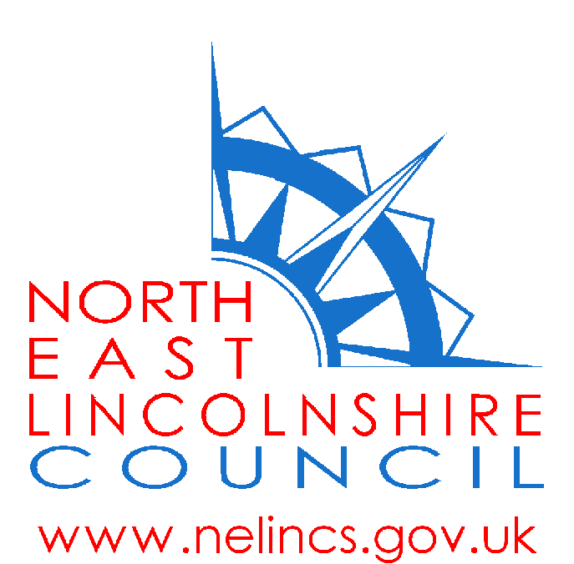

13th June 2017

North East Lincolnshire Council review of the current
Public Space Protection Order (PSPO)

I am writing with regard to a review of the current Public Space Protection Order (PSPO) which restricts the consumption of alcohol in public places. Our current PSPO expires in October 2017 and covers the wards of West Marsh, East Marsh, Park, Heneage, Sidney Sussex, Croft Baker and South.

Whilst it is not an offence to consume alcohol within a PSPO area, the Police have powers to control the consumption of alcohol within that place. If they believe someone is consuming alcohol or intends to consume alcohol they can:

- require them to stop; and
- confiscate the alcohol from people

If someone, without a reasonable excuse, fails to comply with the officer's request they are committing an offence which can result in a penalty notice or a fine.

The following four options are proposed:

- That the PSPO be retained in its current format.

- That the geographical boundaries of the PSPO be reduced, namely to correspond to the Cumulative Impact Zone (CIZ) areas within the high demand wards (https://www.nelincs.gov.uk/wp-content/uploads/2016/01/Statement-of-Licensing-Policy-2015-2020.pdf)

- That the terms or prohibitions be amended.

- That the PSPO be discharged.

The purpose of this letter is to provide you or your organisation with an opportunity to express your views on the above options. As such this is an opportunity for you to be consulted and for the views you express, along with those submitted by other interested parties, to be taken into account in any decisions made.

We are asking that you consider which of the above options you would support and provide any representation or feedback by 31st July 2017.

When considering your response I would be grateful if you could provide, where possible, any evidence you have to support your representations so that we can take this into consideration before making a final decision.

It is anticipated that a decision will be made by the council following consideration of the consultation findings by October 2017. Details of the decision will be published in the local media and further information will be available on the Council’s website.

If you require any further clarification or information then please visit

https://www.nelincs.gov.uk/environment-and-community-safety/community-safety/anti-social-behaviour/ or alternatively you can call telephone 01472 325939.

Kind regards

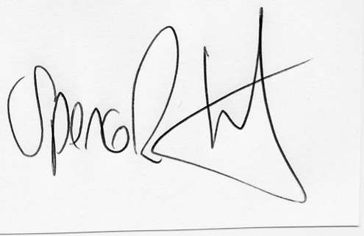

Spencer Hunt
Head of Safer & Stronger Communities
North East Lincolnshire Council

