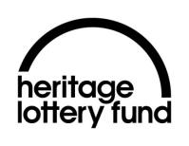
What’s your local heritage?
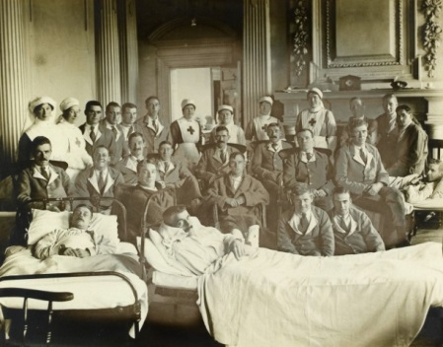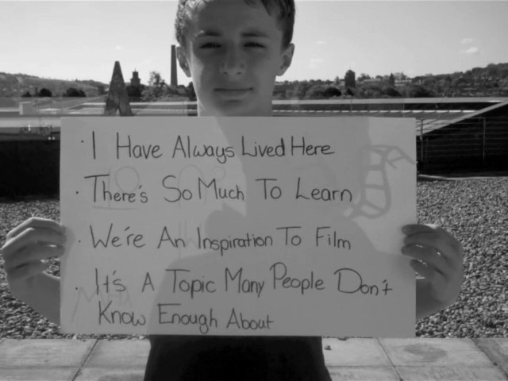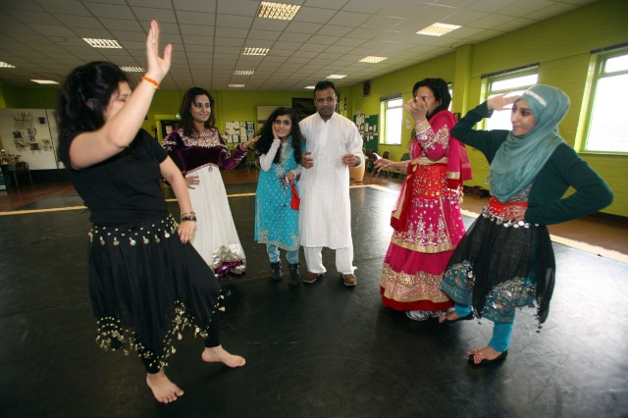

Find out how we can help you apply
for grants from £3k to £100k!
Book on to one of our workshops in our Leeds office now!
Friday 12 May 2017 10am-12noon
Friday 12 May 2017 1pm-3pm
Tuesday 13 June 2017 10am-12noon
Tuesday 13 June 2017 1pm-3pm

yandhdevelopment@hlf.org.uk
Telephone: 0113 3888030

