Northern Lincolnshire Prevention Conference 2016
Summary of participant comments
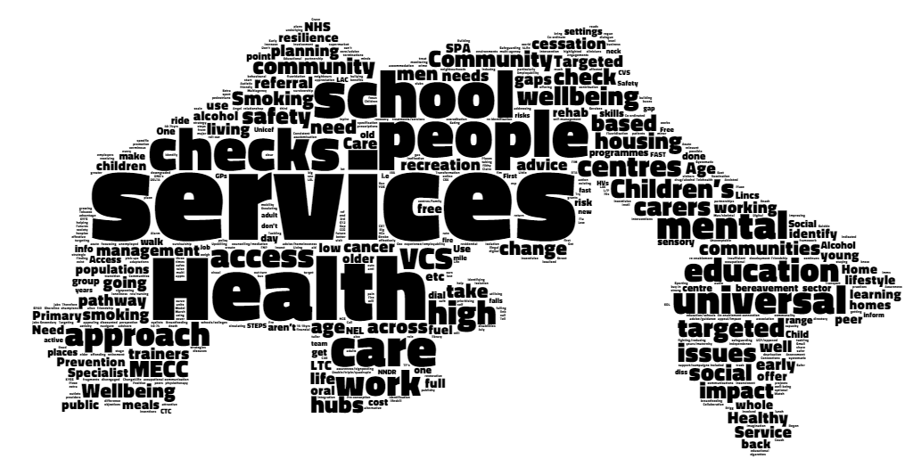

Northern Lincolnshire Prevention Conference 2016
Introduction
On the 21st of July 2016, Professor Chris Bentley delivered a presentation based on the burden of disease report he was commissioned to produce in partnership with the public health teams in North and North East Lincolnshire Councils, as part of Northern Lincolnshire’s 2016 Prevention Conference. Following this presentation, attendees at the conference were asked to work in teams to consider the following, across a variety of age groups, in regards to preventative health:
- What are we already doing? (i.e. what interventions are already in place)
- What are we not doing? (i.e. which groups of patients have we not considered)
- What high impact interventions could we implement (i.e. what could we put in place that would have a high impact upon the health of the population)
Attendees were also asked to consider the following:
- One big idea (i.e. a large scale idea to have a significant impact on the health of the population)
- One low cost idea (i.e. an innovative idea that would not incur much additional cost)
Data Collection
Participants (those attendees who participated in the group activities) were organised into tables of approximately 8-10, with a mixture of participants from various backgrounds – e.g. nurses, doctors, emergency service workers, volunteer sector workers, local authority workers – at each table.
Each table had a member of the public health teams from North East Lincolnshire or North Lincolnshire Council, to facilitate the discussion.
Each table was asked to consider the questions above, for each of the following age groups:
- “Childhood and adolescence” (0-19)
- “Working age” (20-64)
- “Older age” (65+)
Participants’ comments were recorded on post-it notes and stuck onto pre-made flipcharts used to record comments.
Participants’ comments are mostly quoted in text in quotation marks. Some more illustrative quotes are highlighted with blue text.

0-19 - Childhood and Adolescence
What are we currently doing well?
Across all three levels of prevention, a variety of programmes and activities were mentioned.
Childhood and adolescent mental health services (CAMHS) were considered to have a high impact across all three levels of prevention – universal, selective and indicated – and the breadth of the programme was specifically commented on by one workshop participant:
“Children and young people’s mental wellbeing strategies cut across all three [levels of prevention]”
The indicated aspects of the service were also mentioned, with participants highlighting the high impact CAMHS has on autistic spectrum disorders, eating disorders and educational psychology in general.
The broad family and child services programme, e.g. family hubs, children’s centres and perinatal services, were felt to have a high universal impact but little mention was made as to their selective or indicated prevention. The Healthy Child Programme and the ability for health visitors and midwives to identify issues early on and refer appropriately was specifically mentioned:
“Health visiting – onward referral and signposting, early identification”
“…midwives – early dialogue and identification”
Immunisation, screening and vaccination were felt to have a high, universal impact in regards to prevention. Immunisation is an area in which Northern Lincolnshire does considerably well, with current Public Health Outcomes Framework (PHOF) indicators showing uptake rates for North and North East Lincolnshire above the national target for almost all vaccinations and higher than many other local authorities in the region.
A range of children’s activities were mentioned across both universal and selective. Participants mentioned services such as North Lincolnshire’s free swimming initiative for under 16s during the summer, the ‘get going’ programme across Northern Lincolnshire and Change4Life which is delivered locally across Northern Lincolnshire as well as the more general referrals for weight management and exercise.
A wide variety of in-school interventions were referred to across both universal and selective prevention. The universal provision of free-school meals was frequently mentioned by participants, as was the national childhood measurement programme. School nurses, smoking-cessation, sex education, road safety, fire safety, and crime prevention were also mentioned.
Local sexual health services were mentioned by a number of participants, as was the drugs, alcohol and tobacco work carried out, from the universal teaching of the dangers of smoking in schools, right through to selective misuse programmes and the indicated work of services such as Foundations.

Where are the gaps?
A number of participants commented on issues relating to the lack of “joined-up working” such as a lack of strategic cohesion with different teams working to different agendas, teams working in silos or the general concept of a lack of joined up working.
This issue leads into another mentioned by participants, that with the academisation of schools throughout Northern Lincolnshire, many are out of local authority control and this had the potential to lead into a lack of co-operation between schools and the local authorities and “patchy engagement”.
Some participants also mentioned oral health as an area in which we are having limited impact, with some participants questioning whether school dentists still exist and work in schools as they have done in years gone by.
Whilst it was recognised that the CAMHS service has positive, high-impact elements, some participants highlighted areas in which they felt it was not as effective, particularly around “resilience and emotional wellbeing” and pre-CAMHS support.
Underage pregnancy was mentioned as an area in which there has been limited impact, with particular reference to repeat terminations.
Ideas for high-impact interventions
Ideas for high-impact interventions broadly mirrored what participants felt the gaps in prevention currently are.
Ideas such as better access to dentists and fluoridation of water were suggested as was a whole schools approach in order to improve engagement with local schools. Some participants suggested that services were inadequately promoted and this needed resolving.
Other suggestions included a clearer obesity pathway, education on life skills, parental support and better identification of young people who “fall through gaps”.

20-64 - Working Age
What are we currently doing well?
Many participants mentioned the many exercise, dietary and recreational activities being carried out in universal and selective prevention with mention of leisure centres, Change4Life and exercise referral common. There was also mention of adult weight management programmes, fitness programmes like Couch to 5K and Lincs Inspire, a social enterprise partner organisation of North East Lincolnshire Council managing fitness, leisure and libraries across North East Lincolnshire.
There was also much mention of screening, health checks and prevention of specific diseases, e.g. diabetes. Almost every single group of participants in the workshop mentioned either screening, health checks or disease registers as having an impact on universal or selective prevention, highlighting their importance.
A number of groups highlighted the drug, alcohol and tobacco work in regards to prevention, which cuts across selective and indicated prevention, from smoking cessation for all adult smokers to smoking cessation for pregnant women. The majority of groups brought up drug and alcohol work, either in general or specifically mentioning Foundations.
Sexual health and mental health respectively received little mention. Whilst some participants did feel that sexual health services and mental health services, e.g. Navigo, were having an impact on prevention, less than half of groups mentioned it.
Some mention was made in regards to the work of job centres and nursery education for getting people into work and providing childcare allowing people to work, respectively. It was felt that by getting people into work, health improves as a result.
One group of participants mentioned the rehabilitative work in regards to pulmonary, cardiac and stroke services in preventing further complications.
Where are the gaps?
A number of participants spoke of gaps with mental health services. It was mentioned that whilst job centres do get people into work, they do not follow the correct steps for getting unemployed people with mental health services back into work.
It was also mentioned that there are gaps with the provision of mental health services to those with long term physical conditions and that there is a lack of success with early mental health interventions.
The majority of groups brought up issues relating to how services are tailored towards patients. One group felt that services did not know the needs of so-called “hidden communities”, whilst another felt that services did not understand their communities’ “agendas”. Another two groups felt that nearly all services were 9-5 and this adversely affected those of working age. Lastly, one group felt that there was insufficient staff in practices to cope with demand.
Three groups brought up issues relating to occupational health, one group describing it as inconsistent and two groups referring to gaps in occupational health relating to back and neck problems. For one group, this was coupled with a lack of education about what physiotherapy is.
Ideas for high-impact interventions
Ideas for high-impact interventions broadly mirrored what participants felt the gaps in prevention currently are.
Half of the groups identified workplace interventions, particularly in relation to musculoskeletal problems such as back and neck issues. Some suggested open access to physiotherapy, some suggested incentivising workplaces to offer more education on workplace injuries through reduced business rates and some suggested “holistic approaches to neck and back pain”.
Three of the groups had ideas around screening, one including carrying out health checks through pharmacies (specifically supermarket pharmacies) and mobile screening units in areas of high need. They suggested that health checks ought to be “community based…to optimise specification of risks and treatment”.
Another group suggested screening in the workplace and screening by peers.
Three of the groups made reference to employment and/or raising aspiration, either through the broad idea of regeneration through jobs and housing or the more specific idea of: “providing employment advice/guidance from community settings to targeted groups” with the intention of raising aspiration.
Two of the groups suggested developing better understanding of communities with one group giving the suggestion to:
“identify how to incentivise healthy behaviour amongst unhealthy groups”
Other ideas included social prescribing, Making Every Contact Count, “greening” neighbourhoods, road engineering to prioritise pedestrians and cyclists over cars in “poorer areas”, an integrated wellbeing service, residential assisted living to “get people’s lives back on track” and implementing “evidence based approach[es]”.

65+ - Older Age
What are we currently doing well?
References to screening, prevention and surveillance activities were made by almost every group, such as wellbeing checks, screening programmes, health checks, home safety checks, fire safety checks, cancer screening, diabetes prevention and the dementia register. Additionally, wellbeing hubs were mentioned by a small number of groups.
There were also many mentions of the services that make living at home easier and safer for the elderly population, split into services delivered to the home, and services delivered at the home. A number of groups suggested that services such as Dial a Ride and Meals on Wheels had a high impact on the elderly population.
A number of groups suggested that adaptations to elderly housing, be that extra care housing, assisted living or physical adaptations such as railings to prevent falls were also having a high impact. Additionally, a small number of groups also made reference to tele-health and tele-care.
Some groups also mentioned economic programmes aimed at improving the living conditions and healthcare of the elderly population, such as free prescriptions, free off-peak bus travel, discounts in local shops and the winter fuel allowance.
Finally, there was considerable mention of social programmes aimed at reducing social isolation amongst the elderly population as a whole or subgroups of the elderly population, particularly those with dementia.
Walk Well (which has an additional physical benefit), friendship clubs, lunch clubs and community groups were all said to be of high impact across the elderly population. Specifically, a variety of dementia-specific groups such as dementia cafes and dementia friends were mentioned as having a high impact on specific subgroups of the elderly population.
Where are the gaps?
A number of groups brought up that screening does not always reach certain groups and participants mentioned that too few men were taking up the 40-74 health check. Additionally, it was mentioned that there are hard to reach groups for dementia screening and that health visitors no longer visit the elderly.
The lack of a holistic home safety and wellbeing check was also mentioned, as was the lack of bone density screening.
Prevention of musculoskeletal issues was mentioned at the universal, selective and indicated level by one group as was managing the frail and the functional frail mentioned at the selective and indicated level by another group.
As with the 0-19 age group, there was some mention that there are gaps in the prevention of oral health problems amongst the elderly population.
Gaps across the prevention spectrum were highlighted in regards to mental health, from indicated mental health, to selective bereavement counselling and universal isolation and loneliness.
Whilst some groups felt that Dial A Ride was having a high impact, others felt that it was not that effective, with “[a] lack of transport” and “buses to medical centres” being identified as gaps.
It was suggested by two groups that there is little support for carers and family of dementia sufferers.
It was suggested by two groups that there are gaps regarding sensory impairment.
It was suggested by one group that there is no cancer survivorship programme.
Finally, it was suggested by one group that there is insufficient understanding of the needs of the elderly population and their modes of communication.
Ideas for high-impact interventions
There was little consensus or overlap between groups, and many groups were the only group to make a particular suggestion.
Some groups mentioned a variety of screening and checks. One group suggested promoting health checks amongst elderly men and low uptake groups by tailoring them to make them more relevant and appealing. These checks would be carried out in the community rather than in doctors’ surgeries. Another group brought up the idea of a holistic home safety and intervention service.
A variety of other suggestions were put forward including better planning for old age, helping people (e.g. carers) navigate “the system” better, awareness campaigns for long-term conditions, greater appreciation for peer support groups, better services for sensory impairment, supporting people made redundant 55+ and increasing diagnosis in primary care.

Big Ideas and Low Cost Ideas
As part of the group exercises, groups were asked to develop one ‘big’ idea and one low cost idea.
Big Ideas
The most popular big idea was the idea of health checks, mentioned in various forms by four of the eight groups participating.
Two groups highlighted the adaptation and promotion of health checks in order to increase uptake amongst low uptake groups, in particular older men.
One group put forward the idea of a variety of public and private sector workers working in the community, such as health visitors, social workers, safer communities teams and others could carry out holistic health and wellbeing checks on older residents in their own homes. This would create in their words “[a] holistic home safety, health and wellbeing assessment and intervention service”.
Additionally the fourth group suggested “community based health checks and screening to optimise and identify risks”.
The remaining four groups had ideas split between:
- Investment into developing ways to incentivise healthy behaviours amongst groups of patients with fatalistic attitudes towards healthcare.
- A single point of access for sporting and exercise services.
- A vast improvement in healthcare communications taking into account the “digital world” in order to influence health messages
- A central evaluation and impact team to ensure evidence based interventions
Low Cost Ideas
There was much greater variation between groups in regards to their low cost ideas, with many groups coming up with different ideas. However, there was one common theme across a number of groups, and that surrounded a lack of awareness (amongst both patients and healthcare professionals) of what services are offered. This was referred to as “sharing intelligence”, “[a] lack of awareness…” and “…[working] in silos”
- An exercise to map what is offered by all services.
- Sharing intelligence between services.
- Identification of work already being done to avoid working in silos.
- Sharing objectives across the healthcare system.
- Further development of Making Every Contact Count.
- Building on the mile a day programme in schools accompanied by a large increase in business rates for fast food outlets.
- More effective use of social media and technology to better target specific populations and promote services.

