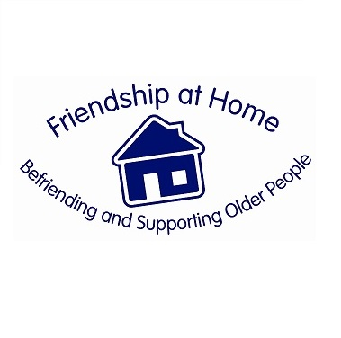

Registered Charity 1160062
Job Description
Dementia Community Support Worker

In partnership with Healthcare Management Trust (HMT Hospitals) - St Hugh’s Hospital we are looking to recruit a Dementia Community Support worker.

Hours 20 hours per week over 4 days

Responsible to The Operational Manager of Friendship at Home (F@H) and the Board of Trustees

Who We Are
Looking for The Dementia Community Support Worker will develop a
Dementia support service. This service will provide practical and emotional support to improve the quality of life for older people, their families, affected others and carers in North East Lincolnshire. The team will work with people throughout their Dementia journey.

Key Skills A thorough understanding, knowledge, and previous experience of:

- The needs of older people with dementia and the problems they face.

- Thorough understanding of Dementia and its presenting problems.

- A thorough understanding of the role of a carer.

- Knowledge of the Voluntary and community sector

- A through knowledge and understanding of the local context of dementia and support services available.

- Recruiting volunteers, supervising, working with, training and managing others

- Excellent communication skills.

- A good understanding and ability to use MS Office

- Ability to liaise with professionals and other organisations

- Patience and sensitivity in difficult and challenging situations.

- Ability to work on one’s own initiative and as part of a team.

- A Full UK Driving Licence with access to a car.

Duties to Include Overall

(Please note other types of tasks may need to be carried out that are not listed below, subject to risk assessments)

      - To support members throughout their dementia journey by providing a one stop service.

      - To establish strong partnership links with relevant organisations and statutory bodies

      - To represent Friendship at Home (F@H) at appropriate meetings and events

      - To be proactive in enabling effective working partnerships and networking with other organisations to promote and develop the project.

      - To take responsibility for managing specified activities and events within the project area and assist in tasks as delegated by the Operational Manager.

      - To support and accompany members/carers on relevant appointments

      - To be proactive in enhancing the aims of Friendship at Home (F@H)

      - To be proactive in following all Health and Safety requirements of Friendship at Home (F@H) and other organisations, and monitor risks as required.

      - To identify new opportunities and assist as required in developing the service

      - To produce reports and updates as required on the project and work undertaken.

      - To attend quarterly Management Committee Meetings (evenings) as required.

      - To work flexibly to meet the needs of Friendship at Home (F@H).

