North East Lincolnshire Local Safeguarding Children’s Board

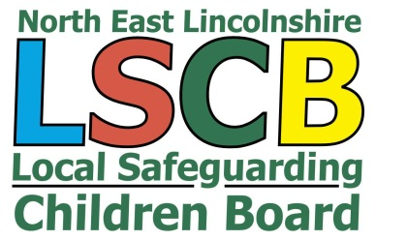
3 Town Hall Square
Grimsby
N E Lincolnshire
DN31 1HX

Telephone: 01472 326118
Fax: 01472 325958
Email: CSRS@nelincs.gcsx.gov.uk

Date: 19th December 2016

To Directors, Managers, Trustees, staff and volunteers in Sports Clubs in North East Lincolnshire
RE: Keeping Children and Young People Safe when taking part in organised sports activities
Dear Sir or Madam,
In light of recent national reports and allegations of child abuse in football clubs, I am writing on behalf of NEL Safeguarding Children Board to offer support and advice on keeping children safe, in the knowledge that protecting children and young people will be one of your key priorities.
At a national level I would like to draw your attention to the Child Protection in Sport Unit website (www.thecpsu.org.uk) This is run by the NSPCC and has a safeguarding self-assessment checklist for you to assess your current safeguarding arrangements: www.thecpsu.org.uk/self-assessment-tool
At a local level, you will already be aware of the NELLSCB procedures and requirements for reporting concerns or allegations about the behaviour or conduct of adults who have contact with children and young people. NEL Local Authority Designated Officer (LADO) manages allegations against adults working with children in a position of trust and can be contacted on: 01472/326118 or emailing jill.alderson@nelincs.gov.uk or david.palmer@nelincs.gov.uk For more information see also: http://www.proceduresonline.com/nelincs/lscb/ Last but not least, if you have immediate or urgent concerns about the safety or welfare of a child you must contact the Multi-Agency Safeguarding Hub (MASH) or Families First Access Point(FFAP) on 01472/326292.
If your concerns are about past or historical allegations, these should in the first instance be reported to the police. Even if the adult concerned is no longer involved with children it is equally important that you raise your concerns with the Police so that past offences can be investigated. In some cases, the police will work with the LADO to prevent further offences being committed
Making judgments about others and when to report concerns can be difficult, so it is important that you use the guidance available, E.g. www.thefa.com/football-rules-governance/safeguarding and observe the relevant umbrella organisation’s policies that cover your sports or activities.
If you require further information regarding safeguarding children in North East Lincolnshire, please visit http://nelsafeguardingchildrenboard.co.uk/
Yours sincerely,
Rob Mayall
LSCB Independent Chair
NEL Safeguarding Children Board

