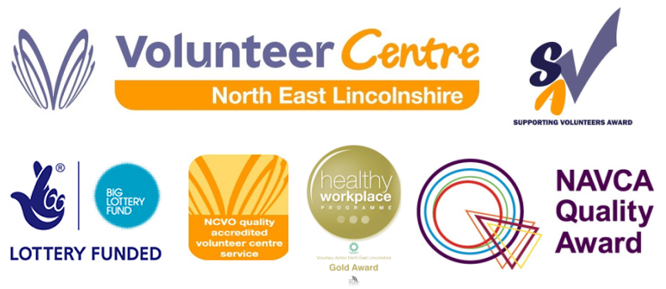
Voluntary Action North East Lincolnshire
Course Booking Form

Your Details
Name |  | Organisation where you volunteer if applicable
Email |  | Org Sector | Vol Statutory Private
Telephone |  | Date of Birth |  | Age
Address  Postcode |  | Please inform us if you  have any special support needs

Booking Details

Course Title |  | Lincolnshire Volunteer Card
Date |  | 8th, 10th, 17th, 24th November, 1st & 8th December  (you must attend all 6 sessions to receive your volunteer card and certificate)
Payment Details
Address for invoice |  | FREE  FULLY FUNDED BY THE TRIBUNE TRUST
Terms and Conditions
Cancellations & refunds: Notification of cancellation is required.
Our refund policy is as follows:
Four or more weeks in advance – full refund, three weeks in advance – 50% refund and two weeks or less – no refund or non-attendance – no refund.
Declaration – I declare that I have checked the information given is correct and authorise you to hold this information on your database and use it in ways which are in line with your aims, and in the ways indicated by the data protection options.
Signed |  |  | Name |  | Date

Please return completed form to : volunteer@vanel.org.uk

