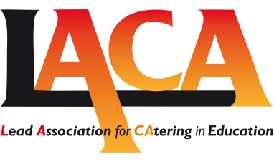
Holiday Hunger/Summer Meals Project
Funding Application – Single Grant 2016
Title | Please enter detail in column below
Name of Project

Date commencing
Project Lead / point of contact

Address

Email
Tel
Bank account details  ( for Fund transfer) | Account:  Sort code:
Summary of Project
A brief outline of set up and aims 100 words max.

Number of days project delivering
Number of weeks project open
Estimated number of children
Total Level of funding required
i.e. x pence per meal X no’s of meals
Brief description of enrichment 100 word max
Is the project open to visits from LACA | YES / NO
Is the project open to any media coverage | YES / NO
Will the project provide details of outcomes that can be shared with others | YES / NO
Signature Project Lead

The above lead will be responsible for delivery of the project and providing necessary details of how the funding has been allocated/used by mid October 2016
Please send PDF to: admin@laca.co.uk

Closing date 24 June 2016

