
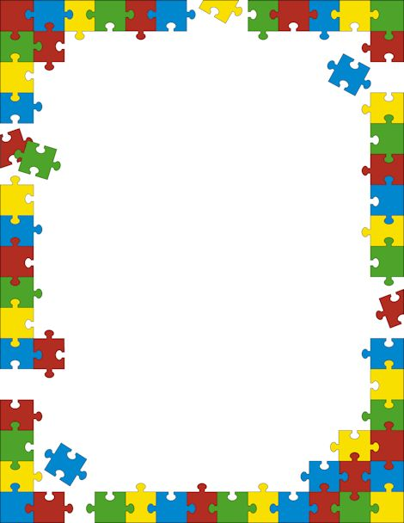
- Crosswords
- Wordsearches
- Sudoku
- Dominoes
- Cards
- Connect 4
- Draughts
- Board games

£2.00 per session
Includes a break with refreshments
Weekly Wednesdays
Starting Wednesday 22 June
2pm – 4pm
Please register your interest at reception

Charity Number 1150939
Games Club

