
Cleethorpes BeachCare Clean Up &
World Oceans Day Activities!
Wednesday 8th June 10.00am
Cleethorpes Discovery Centre, Lakeside, Kings Road, Cleethorpes, DN35 0AG.
Contact: Fiona.mckenna@keepbritinatidy.org 07918739314
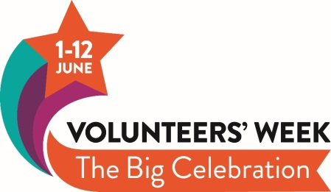
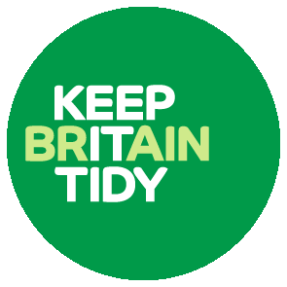
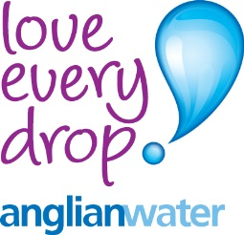
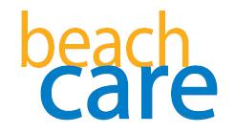
10.00am-12.00pm for the litter pick and surveys. All kit provided just wear outdoor clothing! World Oceans Day activities for all ages will be in the Discovery Centre from 1-4 pm just drop in anytime!

