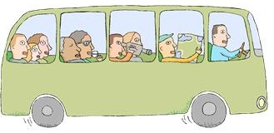

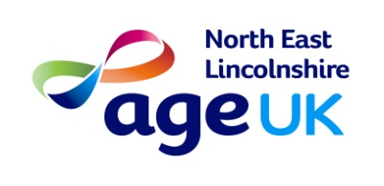
Age Uk Mini bus trip

Louth
on
Friday 13th May
£5 members - £7 non- members

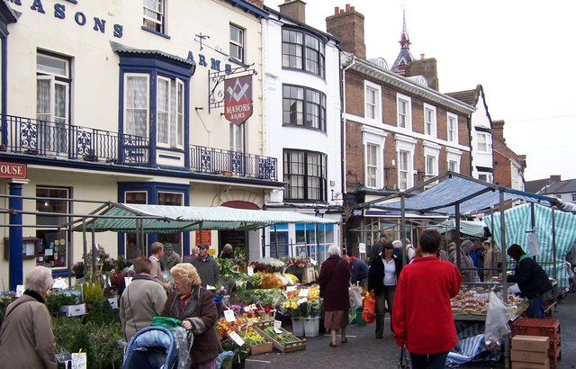
Charity number: 1150939

