
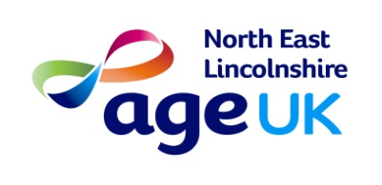 Age UK Mini bus trip
Hornsea
on
Friday 29th July
£14 members - £16 non-members



Charity number: 1150939

