
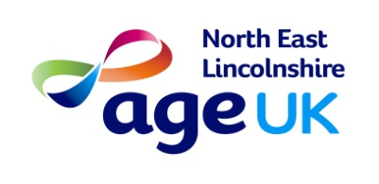

Age UK Mini bus trip

Brigg
Friday 10th June

£7 members - £10 non-members

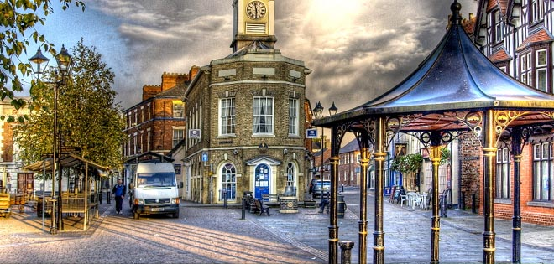

Charity number: 1150939

