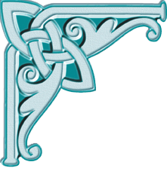

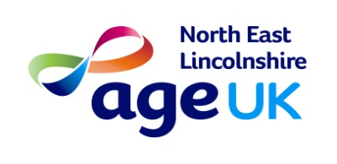
Age UK Mini bus trip
Burton Constable
On
Friday 1st July
£11 members - £13 non-members

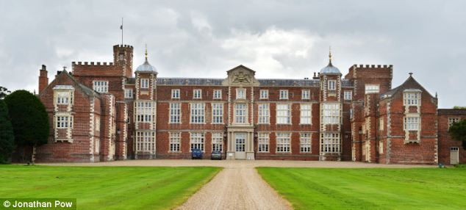

Charity number:1150939

