

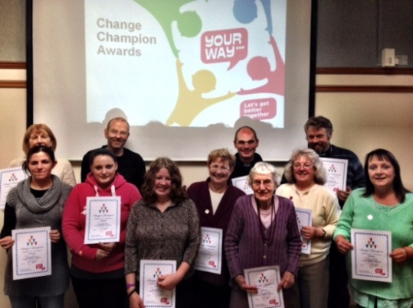


Building Choice
Releasing Community Capacity



Become a
Change Champion
Trainer

Are you interested in becoming a trainer for the Releasing Community Capacity Programme?
As part of the sustainability plan for the Releasing Community Capacity programme we are looking for people to take part in the Change Champions Train the Trainers Course.
With the agreement of your employer you will join a pool of trainers who will train people in your own organisation / community so they can become Change Champions.

If you have previously completed a Change Champions Course you will only need two days training and if you have never completed a Change Champions Course you will need to do a combined four day Change Champion and Train the Trainer course.

If you want to know more contact:
Linda: 07885 979 642 or Kevin: 07980 983 288
