The RCC Board will:
- Provide the training required for the trainers via the delivery partner.
- Offer support in terms of materials and updates
- Co-ordinate and collate the returns from all organisations and share feedback on a quarterly basis.



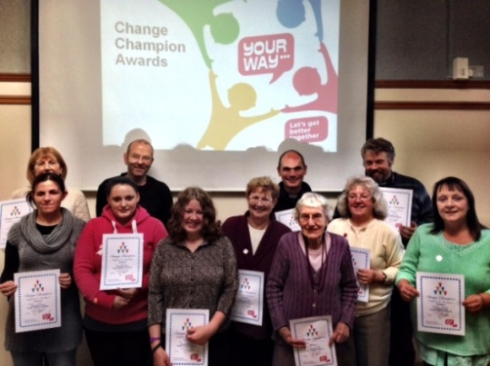
If you want to know more contact:
Linda: 07885 979 642 or Kevin: 07980 983 288
or e-mail RCC@uni.uk.net
www.uniqueimprovements.co.uk


Building Choice
Releasing Community Capacity


Become a
Change Champion
Trainer

Are you interested in becoming a trainer for the Releasing Community Capacity Programme?
As part of the sustainability plan for the Releasing Community Capacity programme we are looking for people to take part in the Change Champions Train the Trainers Course.

With the agreement of your employer you will join a pool of trainers who will train people in your own organisation / community so they can become Change Champions.
If you have previously completed a Change Champions Course you will only need two days training and if you have never completed a Change Champions Course you will need to do a combined four day Change Champion and Train the Trainer course.


The Role of the Trainer:
The designated trainers will be fully trained and supported by the delivery partner until such time as they feel able to undertake the training independently of this support.
Your Organisation Will:
- Identify trainers to be trained
- Allow them the time off to provide training
- Support them to deliver the training
- Provide materials as required
- Provide the venues and catering required in accordance with their own policies.
- Report as requested by the RCC board.
The Change Champion Trainers Will:
- Work within their organisation’s own training and development plans
- Attend the 4-day train the trainer course.
- Offer Change Champion, 3-day training courses to their own staff and the communities those staff serve.
- Offer quarterly health and wellbeing updates to their own organisation.
- Evaluate their own training
- Contribute to the corporate reporting that the organisation will undertake to the RCC board.



