Veg Fest
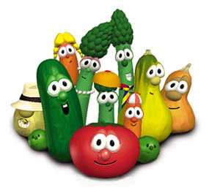

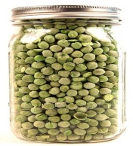


Saturday the 24th of October
11:-00 – 3:00 at

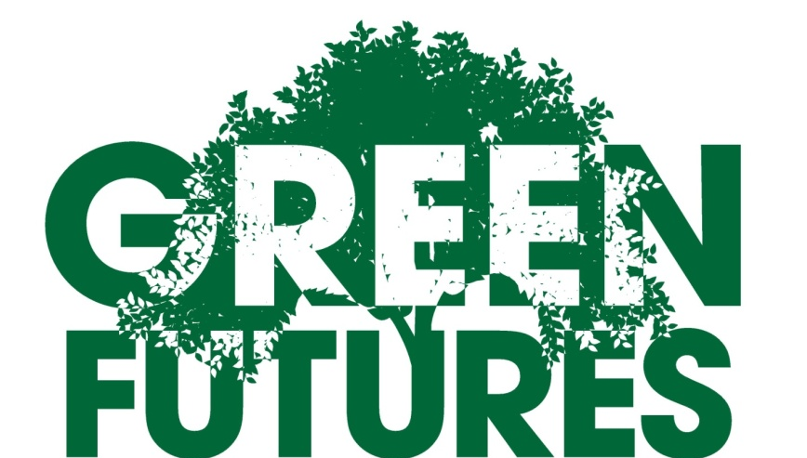

The Vanson Centre Bradley Road, DN37 0AA 0AA

Tel 01472 870609 www.facebook.com/greenfutures

Tombola, Cakes & Refreshments, Workshops, Storytelling, Circus Skills, Scavenger Hunt, Craft Stalls, Info Stands, Plants, Produce, Whole-foods, Eco-products and lots of Fruit and Veg

Please walk, cycle, use the bus or car share, parking is free but restricted

