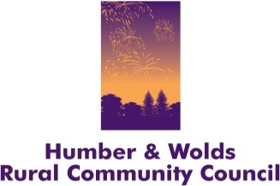

Celebrating 40 Years of Engaging with Our Rural Communities

&

Annual General Meeting

WEDNESDAY, 18 NOVEMBER 2015
The Ropewalk, Maltkiln Rd, Barton-upon-Humber, North Lincolnshire DN18 5JT

Notice is hereby given that the Annual General Meeting of Humber and Wolds Rural Community Council (HWRCC) will be held as above.

Please book your place by emailing: info@hwrcc.org.uk or telephoning 01652 637700

Agenda

1.30pm Arrival, registration and refreshments
An opportunity to meet HWRCC staff and take a look at current and new projects. Also a chance to relive some of the successful projects and services that have been delivered over the past 40 years!
2.15pm Village SOS presentation and Q&A – Chris Cowcher, ACRE
Find out about the Village SOS programme and how it can help in community development or your village project
3.00pm Examples of HWRCC’s current community engagement activities
3.30pm Everyone is welcome to stay for the AGM
3.40pm Annual General Meeting
- Welcome and Introductions
- Apologies for absence
- Minutes from the AGM held on 19 November 2014
- Chairman’s Report
- Annual Review 2014/15
- Trustees Annual Report and Financial Accounts – adoption
- Appointment of Board of Directors
- Appointment of Independent Examiners
- Arrangements for the Annual General Meeting 2016
- Question and Answer session

4.10pm Close of AGM

