The ARK project
Humberside Fire and Rescue Service (HFRS) are embarking on an exciting new project to increase the awareness and abilities of communities, volunteers and agencies to act safely in flood emergencies and keep vulnerable people safe.
The ARK project will see a new water safety and flood response training centre built within the Humberside area to allow agencies, partners and volunteers from across the region and beyond to train in realistic surroundings.
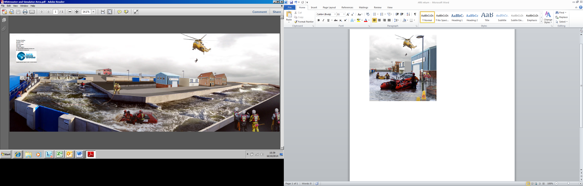
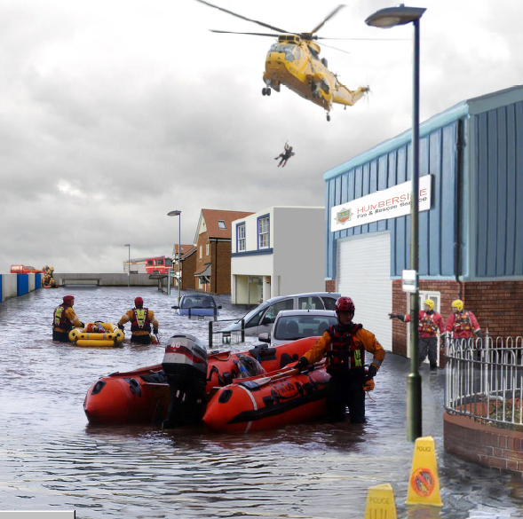
As part of this exciting venture, HFRS are considering the countless possibilities that the ARK would offer and would like to ask if your organisation would have a keen interest in being involved. Some of the potential possibilities include:

A dedicated venue for training staff that may be asked to perform a role prior to (preparation), during (response) and post (recovery) flooding incidents.
A realistic facility to train volunteers, enhancing preparation and recovery activities during flooding incidents.
A location to provide bespoke educational activities to young people in water safety and other subjects.
A facility to provide bespoke team building packages.
Assistance for Parish Council Flood Planning.

The ARK project
Please could you complete the below and return to sduffield@humbersidefire.gov.uk. This will assist in ascertaining all opportunities for developing the concept further.
Name |  | Email
Organisation |  | Telephone No

How could your organisation benefit from the potential use of the ARK?
How many members of your organisation would you envisage being involved in the above?
Does your organisation currently or plan to have funding available for this type of activity?
Any other comments you would like to add.

