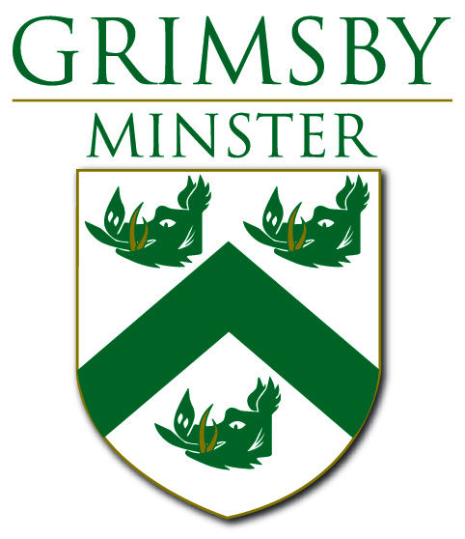
Music Plus at Grimsby Minster – this week
Grimsby Minster St James’ Square Grimsby DN31 1EP
For more information lee.beckett@grimsbyminster.co.uk 01472 358610

Tuesday 28 October 10.30 to 2.30 The Fishy Family Fun Day
run by  Free admission and something for all the family
Face painting – refreshments - food tasting – story telling – arts and crafts activities – games – competitions
- - o 0 o - -
Wednesday lunchtime recitals – hear these young professional musicians before they get too famous
Wednesday 29 October 12.30 pm Merlin’s Keep
Our local, famous, five piece Celtic Folk Rock band! As well as being excellent musicians they are great friends which becomes evident on stage when they synergistic blend of each member produces a forcible energy in performance. Merlin’s Keep pride themselves on their versatility being equally comfortable at traditional fold clubs, community events , celebrations, festival and hardened rock venues!
Recital (£3.00) begins at 12.30 and light lunches are served 11.45 to 2.00 – home-made soups with crusty bread & cheese, hot drinks and a selection of cakes
- - o 0 o - -
Saturday 1 November 7.30pm
The Great War - Voices of the men and women of the First Wold War
Songs, poems, war-time diaries, letters, journals from the trenches and the home-front will recall combatant and civilian experiences, bringing together the well-known words and tunes of wartime writers with previously unseen, unheard new and contemporary material including a suite of songs and poems inspired by the story of the Grimsby Chums.
Tickets £5 from the Minster Office 01472 358610 lee.beckett@grimsbyminster.co.uk
For further information Roger Beard – 07450 107915 – rogerbeard56@yahoo.com

Coming soon ….. The Fabulous Christmas Fair - Christmas with the Choral Scholars of Trinity College Cambridge - Full On Floyd - Merriment and Misrule ‘a Christmas Evening with a difference’

